**EU Declaration of Conformity No. (2014/53/EU)^1**

Note

^1 The assignment of a number to the EU declaration of conformity is optional for the manufacturer.

1. Radio equipment (product, type, batch or serial number):

A: Parking Air Conditioner

B: Diesel Parking Heater WF8002RG WF8006RG

1. Name and address of the manufacturer or his authorised representative:

SUZHOU ROGER AUTO PARTS CO.,LTD.

NO.107,JINSHAN ROAD, SND, SUZHOU CITY JIANGSU, P.R.CHINA

1. This declaration of conformity is issued under the sole responsibility of the manufacturer.

SUZHOU ROGER AUTO PARTS CO.,LTD.

NO.107,JINSHAN ROAD, SND, SUZHOU CITY JIANGSU, P.R.CHINA

1. Object of the declaration (identification of the radio equipment allowing traceability; it may include a sufficiently clear colour image where necessary for the identification of the radio equipment):

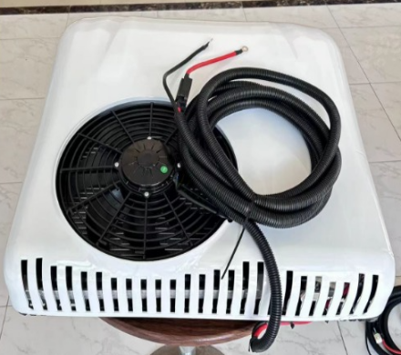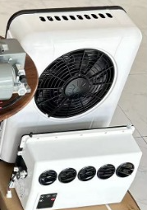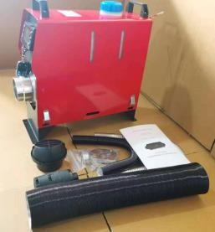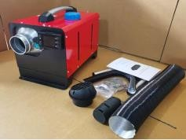

5. The object of the declaration described above is in conformity with the relevant Union harmonisation legislation:

– Directive 2014/53/EU;

– other acts of Union harmonisation legislation (if applicable).

6. References of the relevant harmonised standards used or references of other technical specifications in relation to which conformity is declared. The references are listed together with their identification numbers and version, as well as the date of issue, where applicable: 12/09/2023

7. Where applicable, the notified body BST Testing (Shenzhen)Co., Ltd. RG449232874122211DC

carried out Parking Air Conditoiner and Diesel Parking Heater (description of the intervention) and issued the EU-type examination certificate: Certificate of Compliance

1. Where applicable, a description of the accessories and components, including software, which allow the radio equipment to function as intended and which are included in the EU declaration of conformity:decision 2014/53/EU

9. Additional information:

Signed for and on behalf of: SUZHOU ROGER AUTO PARTS CO.,LTD.

place and date of issue: 02/06/2025

name, function, signature:

